**CS610 Assignment #1 Spring 2022**

***Name: Abdul Rehman.***

***VU-ID: BC200403287.***

**Question No. 1:**

Consider the following network diagram having two LAN segments, each containing three computers. Both the segments are connected with each other through a bridge that manages address list for each LAN segment. Initially when bridge boots, the address list is empty. On occurrence of events (transmission / exchange of messages among computers), the bridge updates its segment list accordingly.

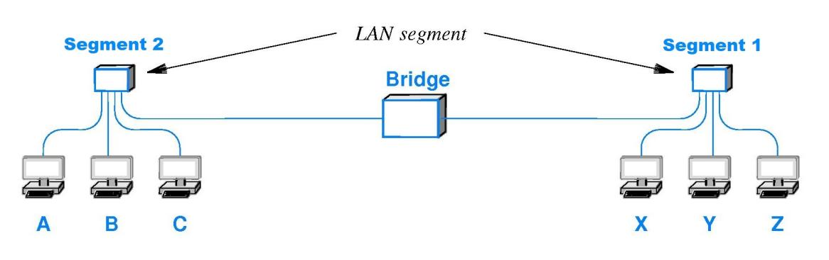

After carefully analyzing the above diagram and the events mentioned in the following table, you are required to fill the segment lists of the bridge associated with each event:

**Solution:**

|  |  |  |
| --- | --- | --- |
| **Event** | **Segment 1 List** | **Segment 2 List** |
| Bridge boots | - | - |
| A broadcasts | - | A |
| X sends message to C | X | A |
| Y sends message to Z | X, Y | A |
| B broadcasts | X, Y | A, B |
| Z sends message to A | X, Y, Z | A, B |

**Question No. 2:**

Mentioned below is a Network Graph to model a WAN. In this graph the nodes represent switches and the edges represents direct connection between switches.

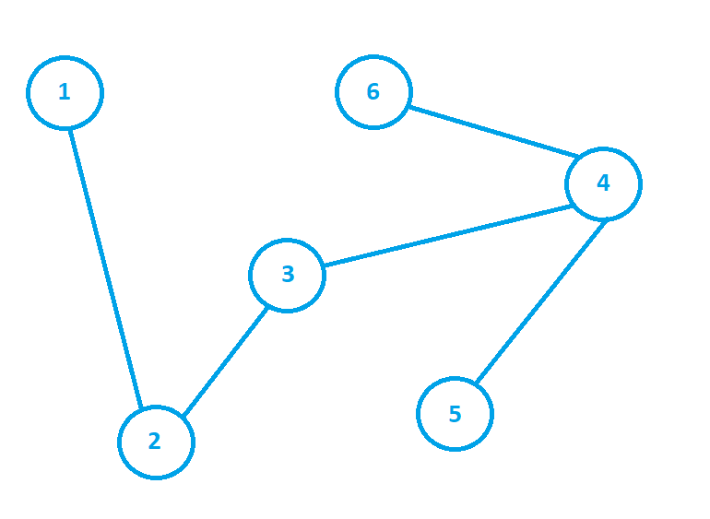

After analyzing the above-mentioned graph, you are required to correctly fill the following routing table by mentioning the next hop information according to the destination for each given node:

**Note:** Format to write the next hop in the table is (Current hop, Next hop).

**Solution:**

|  |  |  |  |  |  |
| --- | --- | --- | --- | --- | --- |
| **Node 1** | | **Node 3** | | **Node 5** | |
| **Destination** | **Next Hop** | **Destination** | **Next Hop** | **Destination** | **Next Hop** |
| 1 | - | 1 | (3, 2) | 1 | (5, 4) |
| 3 | (1, 2) | 2 | (3, 2) | 2 | (5, 4) |
| 4 | (1, 2) | 3 | - | 3 | (5, 4) |
| 5 | (1, 2) | 4 | (3, 4) | 4 | (5, 4) |
| 6 | (1, 2) | 5 | (3, 4) | 5 | - |